ASSIGNMENT

***WAQAS ASHIQ.***

***BCS-F11-201.***

***SECTION C.***

***SUBMITTED TO : Mr.Usman Ashraf***

***EXERCISE#1:***

***CODE:***

#include<stdio.h>

int main()

{

char a,b,c;

char * ptrP,*ptrQ,*ptrR;

ptrP=&a;

ptrQ=&b;

ptrR=&c;

printf("the adrres of a is:\t%p\n",&a);

printf("the adrres of b is:\t%p\n",&b);

printf("the adress of c is:\t%p\n",&c);

printf("\n the address of pointer p is:\t%p\n",ptrP);

printf("\m the naddress of pointer q is:\t%p\n",ptrQ);

printf("\n the address of pointer r is\t:\t%p\n",ptrR);

printf("\n the size of char variable a is: \t%lu\n",sizeof(a));

printf("\n the size of char* is:\t%lu",sizeof(ptrP));

printf("\n\n\n");

return 0;

}

***OUTPUT:***

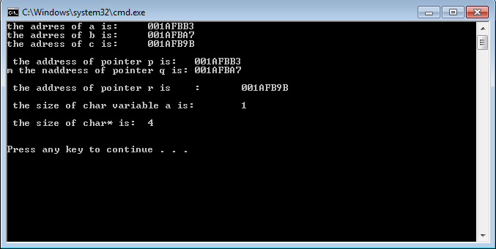

***EXERCISE # 2:***

***CODE:***

#include<stdio.h>

int main()

{

float a[8]={};

float *aPtr;

aPtr=a;

float sum=0;

int counter=2;

for(int i=0;i<=7;i++)

{

printf("enter the number :\t");

scanf("%f",&a[i]);

}

for(int i=0;i<=7;i++)

{

if(i != 1 || i!=3 || i!=5 || i!=7)

{

sum+=a[i];

}

i++;

printf("\nthe %d number in array is :\t%f\n",counter,*(a+i));

counter+=2;

}

printf("\nthe sum of 1st,3rd,5th and 7th number is : %f",sum);

printf("\n\n\n\n");

}

***OUTPUT:***

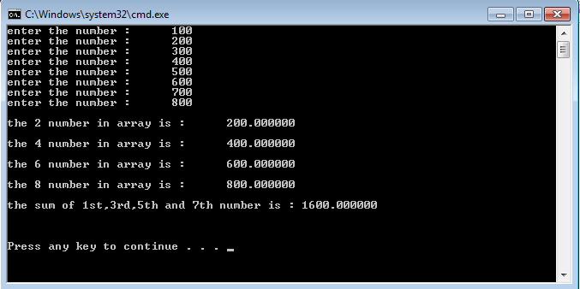

***EXERCISE# 3:***

***CODE:***

#include<stdio.h>

int main()

{

int a[20]={0};

int C;

int B;

int D=0;

int repeat;

int value;

for(C=0;C<=19;C++)

{

printf("Enter the values between 10 to 100:\t");

repeat = 0;

scanf("%d",&value);

for(B=0;B<D;B++)

{

if (value == a[B])

{

repeat=1;

break;

}

}

if( ! repeat)

{

a[D++] = value;

}

}

printf("\nThe non repeating numbers between 10 to 100 are:\t\n");

for(C=0;a[C]!=0;C++)

{

printf("%d\t",a[C]);

}

printf("\n");

return 0;

}

***OUTPUT:***

